Workshop Bad Doberan
Light is life -
masterplan working group
Headed by:
Thomas Röhmhild
Participants:
Stefan Seyler, Wismar/D
Mark Jentsch, Wismar/D
Christoph Menzel, Kassel/D
Georg Werdermann, Wismar/D
Sylvia Mauch, Elze/D
Uta Gehrhardt, Kassel/D
Ingrid Van Steenbergen, Zaventem/B
Theresa Wolf, Kassel/D
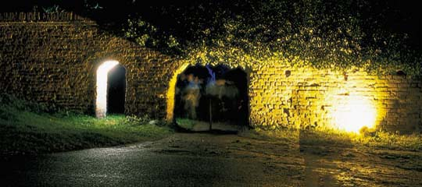
The buildings and ruins in Bad Doberan are evidence of the past life of the monastery and all that went on inside and around it. The individual fragments have now lost their context, however, and stand in relative isolation. Their connection to and significance for life in the monastery is no longer evident. The group headed by Prof. Thomas Römhild had the task of designing lighting to link the fragments remaining on the site of the monastery and to demonstrate the unity they originally comprised.
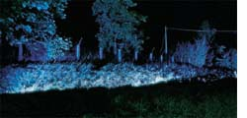
Light was predestined for this task because it is a metaphor for life. The idea of the monastery as a living unit in its own right was to be revived on a temporary basis by linking the ruins and fragments remaining on the site by lighting installations. The walled-in site of the former monastery was seen as a symbol of the life that was led there in its various stages and with its different components. The tangible space the monastery occupies was seen to represent life as a whole. The lighting of the individual buildings and other objects was to underline the different stages of the monks' life. Light was to be applied to demonstrate life at the monastery.
The group's concrete task was to apply light to create a link between the four other working groups and a framework to the workshop as a whole whilst allowing the working groups to work and develop their concepts individually. This was achieved on the one hand by providing linking lighting installations along the paths connecting the various groups and, on the other hand, by outlining the layout of the site through the illumination of the remaining surrounding monastery walls together with the entrances and gateways. The 2000 visitors who came to view the lighting installations were presented with a small candle in a plastic cup. This meant that every visitor was part of the lighting installation in the monastery and in a metaphoric sense living reminders of how life once was in the monastery.
The visitor entered the monastery grounds through illuminated gateways, which symbolised the entrance to life and together with the monastery walls marked the boundaries to the area. Each visitor was given a candle on entering the area, a light to symbolise his life and with which he could fathom the different stages of life. The walls that marked the boundaries to the monastery grounds were lit by candlelight and encompassed the individual stages of life. In contrast to the wall elements there was the stream that runs through the grounds, the life line of the monastery, which was emphasised with blue light.
In the old brewery, which stood for hard work and a place for parties and celebrations, warm and cold light demonstrated the contrast between a celebratory atmosphere and daily routine. The Corn House, which is the most lively location on the site today, took on a more reticent role with its windows discreetly lit in blue. The ruins of the former weaving centre and wool store, the Wool House, was lit sensitively and discreetly to illu-strate the peaceful, quiet moments of life, which underlined the tranquillity of this space. The great contrast to this was the minster itself, which was lit from the inside and symbolised the highlights of monastic life. The roof and the ridge turret were accentuated and appeared to be floating, with the result that the focal point of life at the monastery remained harmoniously discreet. The lighting of the adjoining cemetery with the charnel house (bone house) symbolised the final stage of life at the monastery.
Walking through the grounds along the paths the visitor was able to observe other lighting effects which did not necessarily relate directly to the large structures on site. These were the small facettes of life, which were hardly notice-able, but nevertheless an integral part of the overall site. When the visitor had visited all the locations on the site and extinguished his candle, he was aware that he had been part of monastic life, if only for a short time.

